Zahide Fatma Gül TOPÇU

Eliz YILMAZ

LECTURE NOTES AND EXAMPLES FOR WEEK 12
April 29 & May 1, 2008
GUI: GRAPHICAL USER INTERFACE

Event-Driven Programming

Conventional programming
Begins
↓
Input Output (depends on the input)

→ →

↓
Ends

For each possible event we have a separate program to address the
event.

Decimal

Output no

5
Convert to
hex
Binary
oct

Events
- Pushing a button
- Moving mouse
- Clicking mouse
- Entering a value into a field
↑
Event Listeners
Awt → Abstract Window Toolkit
Swing

→ →
Component
Event
Listener

button button does the necessary thing for that button
(Objects) click possibilities
perform a calculator
close window
open window

In the event based programming the swing system automatically invokes certain methods when an event signals that the method needs to be invoked (called).

Swing Example

import javax.swing.*;

public class FirstSwingDemo {

public static final int width=300;
public static final int height=200;

public static void main (String []args)
{
JFrame mywindow = new JFrame();
mywindow.setSize(width, height);

JLabel myLabel= new JLabel(“ Hello World ”);
get ContentPane().add(myLabel);
mywindow.setVisible(true);
mywindow.addwindowListener(new WindowDestroyer());
}// end of main
}//end of FirstSwingDemo

import java.awt.*;

public class WindowDestroyer extends WindowAdapter {

public void windowClosing(Window event e)
{
System.exit(0); →exit the program and go back tooperating system
}
}

A window with colors

Color.BLACK
BLUE
GRAY → import java.awt.*;
GREEN
.
.

import javax.swing.*;
import java.awt.*; //(for colors)

public class SecondWindow extends JFrame
{
width, height
public SecondWindow()
{
setSize(width, height);
Container contentPane = getcontentPane();
contentPane.add(label);
setTitle(“SecondWindow”);
contentPane.setBackground(Color.BLUE);
add.windowListener(new WindowDestroyer);
}
import java.awt.*; //(for colors)

public class SecondWindowDemo
{
public static void main (String []args)
{
SecondWindow window1 = new SecondWindow();
SecondWindow window2 = new SecondWindow(Color.ORANGE);

Window1.setVisible(true);
Window2.setVisible(true);
}
}

public class SecondWindow (Color customColor)
{
width, height
public SecondWindow()
{
setSize(width, height);
Container contentPane = getcontentPane();
contentPane.add(label);
setTitle(“SecondWindow”);
contentPane.setBackground(Color.BLUE);
add.windowListener(new WindowDestroyer);
contentPane.setBackground(Custom Color)
}

USER INTERFACE
Container classes : JFrame , JPanel , JApplet,...
Component classes : JButton , JLabel , JTextArea ,...
Helper classes : Color , Font , LayoutManager,...

Creating a Frame a simple example:

import javax.swing.*;
public class myFrame
{
public static void main (String[] args)
{
JFrame frame = new JFrame ("My Frame");
frame.setSize(400,300);
frame.setDefaultCloseOperation(JFrame.EXIT_ON_CLOSE);
JButton myButton = new JButton("OK");
frame.add(myButton);
frame.setVisible(true);
}
}

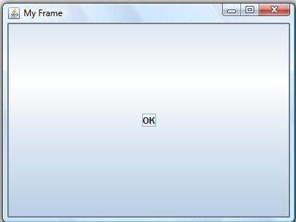

LAYOUT TYPES:

Flow Layout : (default layout type)

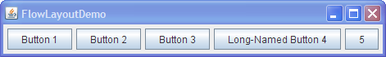
Flow Layout Example:

import java.awt.*;
import javax.swing.*;

public class FlowPanel extends JPanel
{
public FlowPanel()
{
setLayout(new FlowLayout());
setBackground(Color.green);
JButton b1 = new JButton("Button 1");
JButton b2 = new JButton("Button 2");
JButton b3 = new JButton("Button 3");
JButton b4 = new JButton("Button 4");
JButton b5 = new JButton("Button 5");
add(b1);
add(b2);
add(b3);
add(b4);
add(b5);
}
}

Grid Layout:

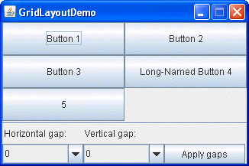
Grid Layout Example:

import java.awt.*;
import javax.swing.*;

public class GridPanel extends JPanel
{
public GridPanel()
{
setLayout(new GridLayout(2,3));
setBackground(Color.green);
JButton b1 = new JButton("Button 1");
JButton b2 = new JButton("Button 2");
JButton b3 = new JButton("Button 3");
JButton b4 = new JButton("Button 4");
JButton b5 = new JButton("Button 5");
add(b1);
add(b2);
add(b3);
add(b4);
add(b5);
}
}
Border Layout:

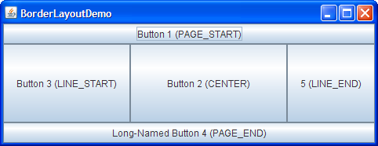

Border Layout Example:

import java.awt.*;
import javax.swing.*;

public class BorderPanel extends JPanel
{
public BorderPanel()
{
setLayout(new BorderLayout());
setBackground(Color.green);
JButton b1 = new JButton("Button 1");
JButton b2 = new JButton("Button 2");
JButton b3 = new JButton("Button 3");
JButton b4 = new JButton("Button 4");
JButton b5 = new JButton("Button 5");
add(b1,BorderLayout.CENTER);
add(b2, BorderLayout.NORTH);
add(b3, BorderLayout.SOUTH);
add(b4, BorderLayout.EAST);
add(b5, BorderLayout.WEST);
}
}

Box Layout: (opposite of the flow layout)

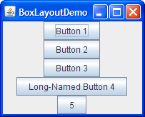

Box Layout Example:

import java.awt.*;
import javax.swing.*;

public class BoxPanel extends JPanel
{
public BoxPanel()
{
setLayout(new BoxLayout(this, BoxLayout.Y_AXIS));
setBackground(Color.green);
JButton b1 = new JButton("Button 1");
JButton b2 = new JButton("Button 2");
JButton b3 = new JButton("Button 3");
JButton b4 = new JButton("Button 4");
JButton b5 = new JButton("Button 5");
add(b1);
add(b2);
add(b3);
add(b4);
add(b5);
}
}

Layout Demo:

import javax.swing.*;
public class LayoutDemo
{
public static void main(String args[])
{
JFrame frame = new JFrame("Layout Manager Demo");
frame.setDefaultCloseOperation(JFrame.EXIT_ON_CLOSE);
JTabbedPane tp = new JTabbedPane();
tp.addTab("Flow" , new FlowPanel());
tp.addTab("Border" , new BorderPanel());
tp.addTab("Grid" , new GridPanel());
tp.addTab("Box" , new BoxPanel());
frame.getContentPane().add(tp);
frame.pack();
frame.setVisible(true);
}
}

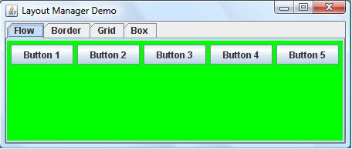

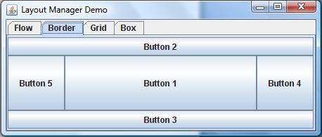

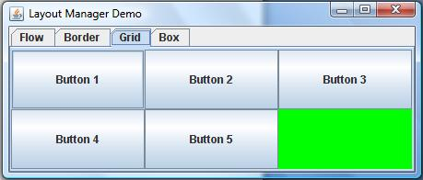

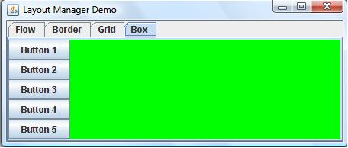

EXAMPLE: (calculating the circumference and area of a circle)

import java.awt.*;
import java.awt.event.*;
import javax.swing.*;
import java.text.DecimalFormat;

public class Circle extends JFrame implements ActionListener {
// Declare the GUI components and other variables as needed
private JLabel radiusLabel, resultLabel;
private JTextField radiusField, resultField;
private JButton circumferenceButton, areaButton;

public Circle()
{
Container c = getContentPane();

c.setLayout( new FlowLayout() ); // Set the layout type for
// placement of GUI components

radiusLabel = new JLabel( "Radius" ); // Create the JLabel object
c.add( radiusLabel ); // Add to container

radiusField = new JTextField( 10 ); // Create the JTextField object
c.add( radiusField ); // Add to container

resultLabel = new JLabel( "Result" ); // Create the JLabel object
c.add( resultLabel ); // Add to container

resultField = new JTextField( 10 ); // Create the JTextField object
resultField.setEditable( false );
c.add( resultField ); // Add to container

circumferenceButton = new JButton("Circum");// Create the JButton
circumferenceButton.addActionListener(this);// Add to ActionListener
c.add(circumferenceButton); // Add to container

areaButton = new JButton("Area"); // Create the JButton
areaButton.addActionListener( this ); // Add to ActionListener
c.add(areaButton); // Add to container
}

public void actionPerformed( ActionEvent e )
{
// local parameters
double circumference, area, radius;

// if event source is "circumferenceButton" object
if (e.getSource() == circumferenceButton) {
// Get the radius entered by user
radius = Double.parseDouble( radiusField.getText() );

// Calculate the circumference
circumference = 2 * Math.PI * radius;

// Round the output to three decimal places
DecimalFormat fmt = new DecimalFormat("0.###");

// Show the result within the JTextField object
resultField.setText( fmt.format(circumference) );
}
// if event source is "areaButton" object
if (e.getSource() == areaButton ) {
// Get the radius entered by user
radius = Double.parseDouble( radiusField.getText() );

// Calculate the area
area = Math.PI * Math.pow(radius, 2);

// Round the output to three decimal places
DecimalFormat fmt = new DecimalFormat("0.###");

// Show the result within the JTextField object
resultField.setText( fmt.format(area) );
}
}

public static void main( String [] args ){
Circle myApi = new Circle();
// Close the application when the form's X icon is clicked
myApi.setDefaultCloseOperation(JFrame.EXIT_ON_CLOSE);

myApi.setLocation(500, 250);
myApi.setTitle("Circle application"); // Set the form's title
myApi.setSize(200, 150); // Set the frame's size
myApi.setVisible(true); // Make the frame visible
}
}
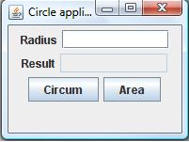

EXAMPLE: (calculating the hypotenuse of a triangle)
import java.awt.*;
import java.awt.event.*;
import javax.swing.*;
import java.text.DecimalFormat;

public class Triangle extends JFrame implements ActionListener {
private JLabel side1Label, side2Label,hypotenuseLabel;
private JTextField side1Field, side2Field,hypotenuseField;
private JButton calculateButton;

public Triangle(){

Container c = getContentPane();
c.setLayout( new FlowLayout() );

side1Label = new JLabel( "Side1" );
c.add( side1Label );

side1Field = new JTextField( 10 );
c.add( side1Field );

side2Label = new JLabel( "Side2" );
c.add( side2Label );

side2Field = new JTextField( 10 );
c.add( side2Field );

hypotenuseLabel = new JLabel( "Hypotenuse" );
c.add( hypotenuseLabel );

hypotenuseField = new JTextField( 10 );
hypotenuseField.setEditable( false );
c.add( hypotenuseField );

calculateButton = new JButton("Calculate");
calculateButton.addActionListener(this);
c.add(calculateButton);

}

public void actionPerformed( ActionEvent e ){
double side1, side2, hypotenuse;

if (e.getSource() == calculateButton){
side1 = Double.parseDouble( side1Field.getText() );

side2 = Double.parseDouble( side2Field.getText() );

hypotenuse=Math.sqrt(side1*side1+side2*side2);

DecimalFormat fmt = new DecimalFormat("0.###");

hypotenuseField.setText( fmt.format(hypotenuse) );

}
}

public static void main( String [] args ){
Triangle myApi = new Triangle();
myApi.setDefaultCloseOperation(JFrame.EXIT_ON_CLOSE);
myApi.setLocation(500, 250);
myApi.setTitle("Triangle application");
myApi.setSize(200, 120);
myApi.setVisible(true);
}
}
